Homogeneous Solutions of Hill Equation – A Report
Luke Hyungchan Kim

1. Introduction
The objective of this report is to analyze the orbits of TerraSAR and TanDEM-X using the given ephemeris data. Each ephemeris file contains six-column Cartesian state vectors: the first three columns represent the satellite position vector in meters, and the last three columns represent the satellite velocity vector in meter per second. The data cover 30 hours with a sampling interval of 10 seconds.
The first part of the report investigates the absolute and relative motion of the two satellites in the inertial frame and in an orbit-fixed reference frame related to TerraSAR. The second part uses the homogeneous Hill equations to model the unperturbed relative motion of TanDEM-X with respect to TerraSAR. The Hill solution is fitted to the true relative orbit by estimating the initial relative position and velocity using a Least Squares procedure.

2. Methods
The ephemeris data were first imported into MATLAB and separated into position and velocity matrices for TerraSAR and TanDEM-X. The relative position and velocity vectors were computed as
$$Δr=r_{TanDEM-X}-r_{TerraSAR}$$
and
$$Δv=v_{TanDEM-X}-v_{TerraSAR}$$
From these vectors, the distance between the two satellites, the magnitude of the velocity difference, and the radial velocity were calculated. The radial velocity was obtained by projecting the relative velocity vector onto the direction of the relative position vector.
An orbit-fixed reference frame was then defined with TerraSAR as the origin. The z-axis was chosen as the radial direction, the y-axis as the crosstrack direction, and the x-axis as the tangential direction of motion. The unit vectors of this frame were computed from the TerraSAR position and velocity vectors. Position and velocity vectors were transformed into this local frame by taking their scalar products with the local basis vectors.
The mean motion of TerraSAR was estimated from the orbit. The geocentric distance was calculated from the TerraSAR position vector at each epoch. Since the orbit is nearly circular, the mean geocentric distance was used as an approximation of the semimajor axis. Kepler's third law was then used to compute the mean motion:
$$n=\sqrt{μ/a^{3}}$$
Here, μ is the Earth gravitational parameter and a is the approximated semimajor axis.
Finally, the homogeneous Hill equations were used to describe the unperturbed relative motion of TanDEM-X with respect to TerraSAR. The initial conditions of the Hill solution were determined by an inverse Least Squares calculation. Only the satellite positions between epochs 2000 and 9000 were used for this fit. Since the x- and z-components are coupled in the Hill equations, they were solved together, while the y-component was solved separately. The obtained initial conditions were then inserted back into the Hill equations to generate the unperturbed relative motion.

3. Results and Comments
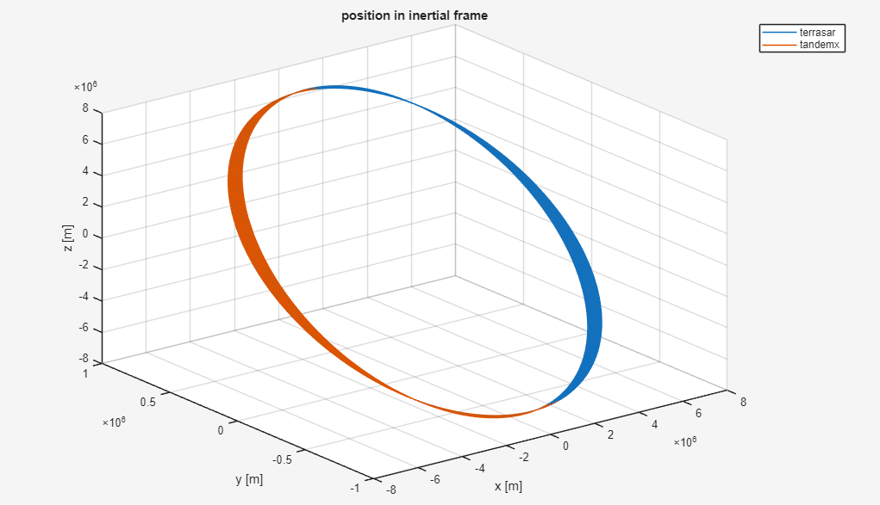
Figure 1. TerrasSAR and TanDEM-X 3d -trajectory around the earth.
Figure [1] shows the inertial orbits of TerraSAR and TanDEM-X. The two trajectories almost overlap because the satellites fly in a very close formation. Compared with the orbital radius, the separation between the two satellites is very small, so the difference between the two absolute orbits is hardly visible in the inertial-frame orbit plot.
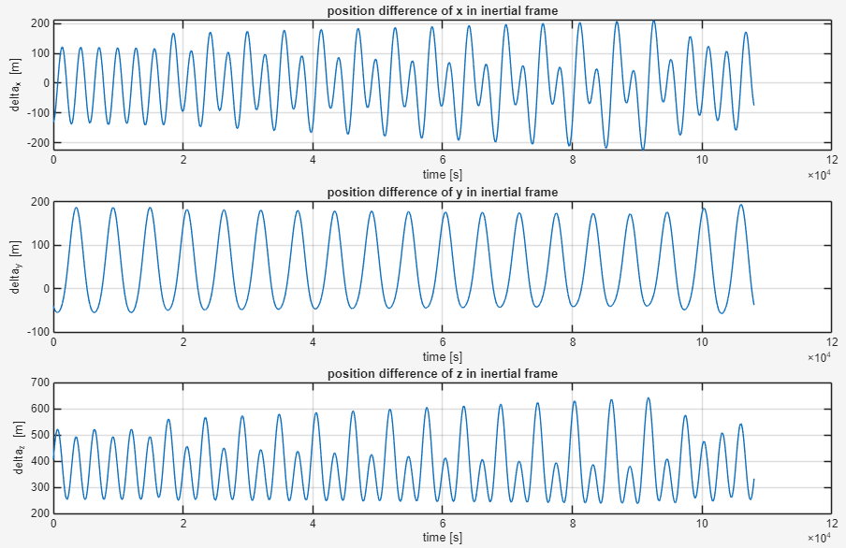
Figure 2. Position difference of TerraSAR and TanDEM-X in Earth Central Inertial Frame
Figure [2] shows the components of the relative position vector in the inertial frame. The components vary periodically with time, which is expected for two satellites flying in a close formation. The variation is caused by the relative motion between the satellites as well as by the rotation of the orbital geometry in the inertial frame.
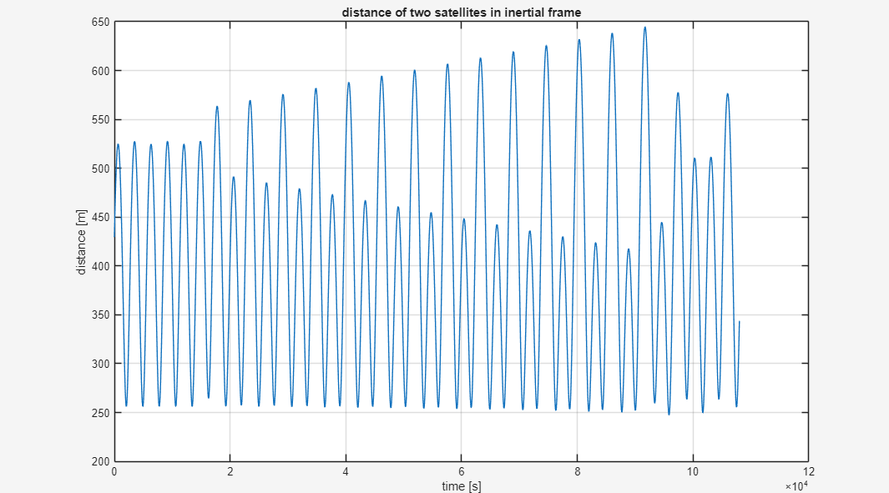
Figure 3. Distance between TerraSAR and TanDEM-X
Figure [3] shows the distance between TerraSAR and TanDEM-X. The distance remains bounded and is on the order of [insert distance scale, e.g. several hundred meters]. This confirms that the satellites remain in close formation during the analyzed time interval. If small discontinuities or changes in the trend are visible, they can be related to manoeuvres or perturbation effects in the provided orbit data.
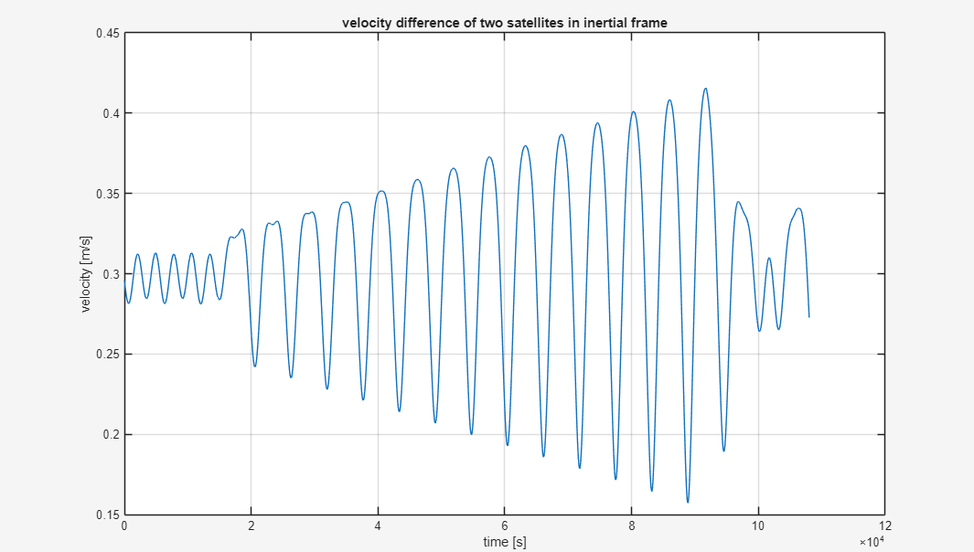
Figure 4. Velocity difference of TanDEM-X and TerraSAR
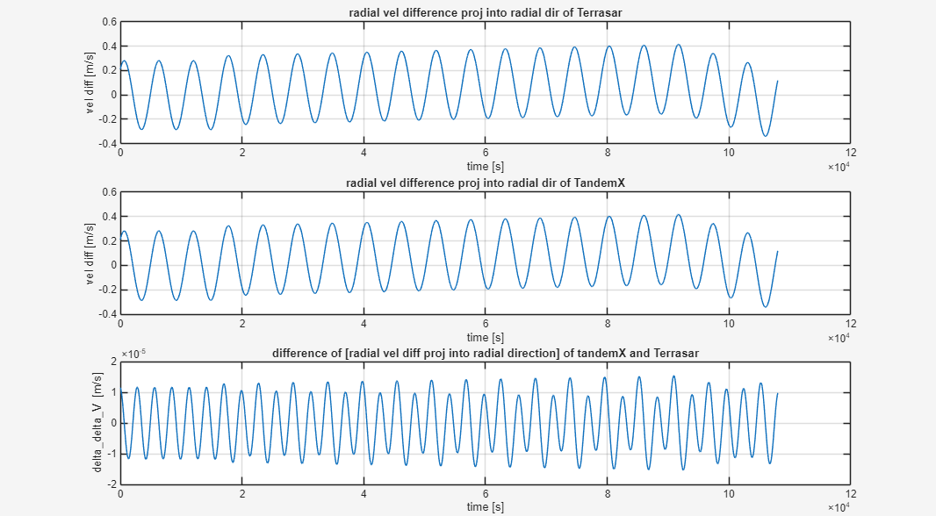
Figure 5. Radial velocity difference (the upper two graphs) projected to each Terrasar and TandamX, and the difference of two differences (lowest graph)
Figure [4], [5] shows the magnitude of the velocity difference and the radial velocity. The relative velocity is much smaller than the absolute orbital velocity, which is consistent with close formation flight. The radial velocity changes sign over time, meaning that TanDEM-X alternately moves away from and toward TerraSAR along the relative position direction.
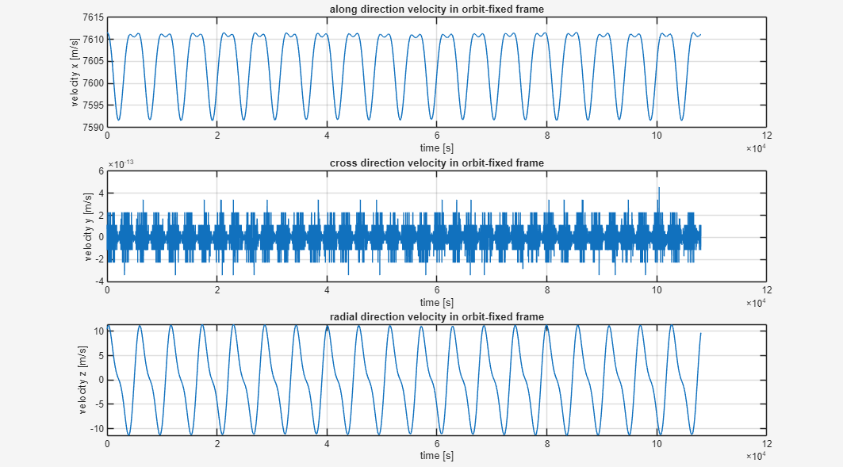
Figure 6. TerraSAR velocity in TerraSAR-centered orbit-fixed reference frame
Figure [6] shows the components of the TerraSAR velocity vector in the orbit-fixed reference frame. The x-component is dominant because the x-axis is defined in the tangential direction of motion. The y- and z-components are much smaller. This is reasonable because, for a nearly circular orbit, the velocity is mainly tangential, while the radial and crosstrack components should be close to zero. Small nonzero components can be explained by the fact that the real orbit is not perfectly circular and is affected by perturbations.
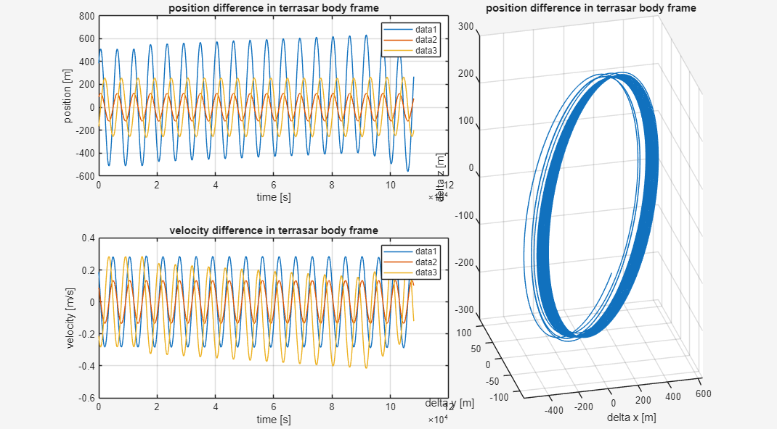
Figure 7. Position and velocity difference(left two graphs), and 3D TanDEM-X trajectory in TerraSAR body fram
Figure [7] shows the relative position and velocity of TanDEM-X with respect to TerraSAR in the orbit-fixed frame. In this frame, the relative motion becomes easier to interpret than in the inertial frame. The motion is bounded and shows the formation-flying geometry around TerraSAR.
The mean geocentric distance of TerraSAR was calculated as
a ≈ 6888.0703 km.
Using Kepler's third law, the corresponding mean motion was obtained as
n = 0.0011 rad/s.
This corresponds to an orbital period of approximately
T = 5689.2804 s.
The obtained period is consistent with a low Earth orbit. The approximation of using the mean geocentric distance as the semimajor axis is reasonable because TerraSAR is in a nearly circular orbit.
The Least Squares adjustment using epochs 2000 to 9000 gave the following initial conditions for the Hill solution:
x0 = 390.1229 m
y0 = 88.5886 m
z0 = -176.8758 m
vx0 = 0.3903 m/s
vy0 = 0.0914 m/s
vz0 = 0.2072 m/s
These values represent the initial relative state of TanDEM-X with respect to TerraSAR in the local orbit-fixed frame. Since many position observations were used to estimate only six initial values, the Least Squares solution gives the best-fitting initial condition for the simplified Hill model over the selected time interval.
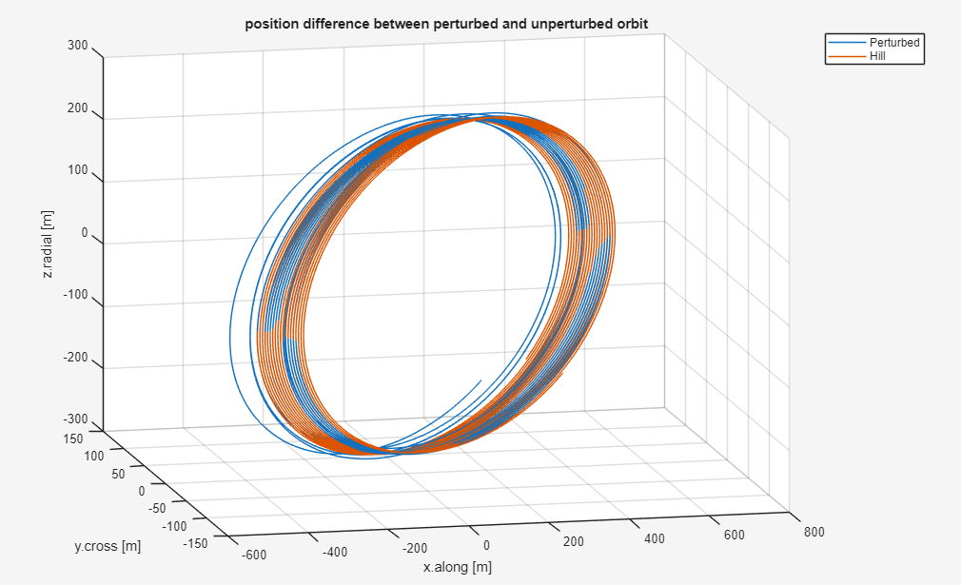
Figure 8. Perturbed and unperturbed orbit trajectory in TerraSAR reference frame
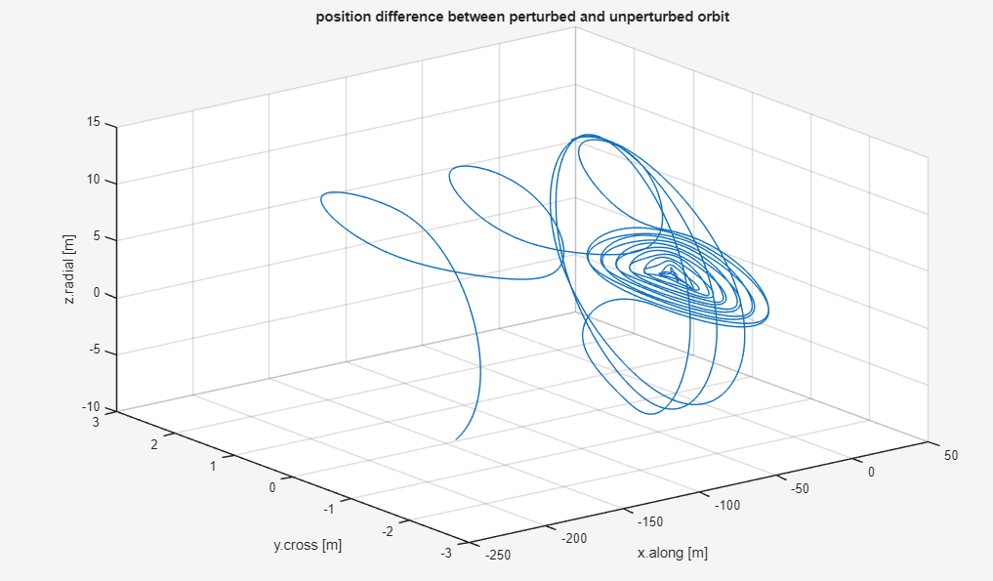
Figure 9. Position difference between perturbed and unperturbed orbit in TerraSAR reference frame
Figure [8],[9] compares the relative motion obtained from the Hill equations with the true relative orbit from the ephemeris data. The Hill solution follows the main shape of the relative motion, which shows that the homogeneous Hill equations provide a useful first-order approximation for the close formation. Nevertheless, small differences remain between the perturbed and unperturbed relative motion. These differences are expected because the Hill equations assume a circular reference orbit and neglect perturbations such as Earth gravity field effects, atmospheric drag, and orbit correction manoeuvres.
Overall, the comparison shows that the homogeneous Hill equations can represent the main relative motion of TanDEM-X around TerraSAR, but they cannot reproduce all details of the numerically integrated orbit data.

4. Conclusion
In this exercise, the TerraSAR and TanDEM-X ephemeris data were processed and analyzed using MATLAB. The absolute orbits, relative position, relative velocity, distance, and radial velocity were displayed in the inertial frame. An orbit-fixed reference frame centered at TerraSAR was also implemented, which made the relative motion of TanDEM-X easier to interpret.
The mean motion of TerraSAR was estimated by approximating the semimajor axis with the mean geocentric distance and applying Kepler's third law. The result was consistent with the expected orbital period of a low Earth orbit.
The homogeneous Hill equations were then used to model the unperturbed relative motion of TanDEM-X with respect to TerraSAR. The initial relative position and velocity were estimated using a Least Squares adjustment over epochs 2000 to 9000. The resulting Hill solution reproduced the main behavior of the true relative orbit, but small deviations remained due to the simplifying assumptions of the Hill model and the perturbations included in the real ephemeris data.

Appendix
MATLAB script: main.m
clear; clc; close all;

terrasar = readmatrix("terrasar.eph", "FileType", "text");
tandemx = readmatrix("tandemx.eph", "FileType", "text");

r1 = terrasar(:,1:3);
v1 = terrasar(:,4:6);
r2 = tandemx(:,1:3);
v2 = tandemx(:,4:6);
time = linspace(0,108000,10801);

% task01(r1, v1, r2, v2, time);
% task02(r1, v1, r2, v2, time, []);
% task03(r1, v1, r2, v2, time)
% task04(r1, []);
% task05(r1, v1, r2, v2, time, []);
% task06(r1, v1, r2, v2, time);

Additional functions used:
task01.m / data loading and plotting
function task01(r1, v1, r2, v2, time)
figure;
plot3(r1(:,1), r1(:,2), r1(:,3), r2(:,1), r2(:,2), r2(:,3));
grid on;
xlabel('x [m]');
ylabel('y [m]');
zlabel('z [m]');
title('position in inertial frame');
legend('terrasar', 'tandemx');

figure;
subplot(3, 1, 1);
plot(time, r1(:,1)-r2(:,1));
grid on;
xlabel('time [s]');
ylabel('delta_x [m]');
title('position difference of x in inertial frame');

subplot(3, 1, 2);
plot(time, r1(:,2)-r2(:,2));
grid on;
xlabel('time [s]');
ylabel('delta_y [m]');
title('position difference of y in inertial frame');

subplot(3, 1, 3);
plot(time, r1(:,3)-r2(:,3));
grid on;
xlabel('time [s]');
ylabel('delta_z [m]');
title('position difference of z in inertial frame');

figure;
plot(time, sqrt((r1(:,1)-r2(:,1)).^2+(r1(:,2)-r2(:,2)).^2+(r1(:,3)-r2(:,3)).^2));
grid on;
xlabel('time [s]');
ylabel('distance [m]');
title('distance of two satellites in inertial frame');

figure;
plot(time, sqrt((v1(:,1)-v2(:,1)).^2+(v1(:,2)-v2(:,2)).^2+(v1(:,3)-v2(:,3)).^2));
grid on;
xlabel('time [s]');
ylabel('velocity [m/s]');
title('velocity difference of two satellites in inertial frame');

figure;
subplot(3, 1, 1);
unit_r1 = r1 ./ vecnorm(r1, 2, 2);
radial_v1 = dot(v1-v2, unit_r1, 2);
plot(time, radial_v1);
grid on;
xlabel('time [s]');
ylabel('vel diff [m/s]');
title('radial vel difference proj into radial dir of Terrasar');

subplot(3, 1, 2);
unit_r2 = r2 ./ vecnorm(r2, 2, 2);
radial_v2 = dot(v1-v2, unit_r2, 2);
plot(time, radial_v2);
grid on;
xlabel('time [s]');
ylabel('vel diff [m/s]');
title('radial vel difference proj into radial dir of TandemX');

subplot(3, 1, 3);
plot(time, radial_v1 - radial_v2);
grid on;
xlabel('time [s]');
ylabel('delta\_delta\_V [m/s]');
title('difference of [radial vel diff proj into radial direction] of tandemX and Terrasar');
end

task02.m / relative position and velocity calculation
function [r, v] = task02(r1, v1, r2, v2, time, mode)
unit_z = r1 ./ vecnorm(r1, 2, 2);
y = cross(r1, v1, 2);
unit_y = y ./ vecnorm(y, 2, 2);
unit_x = cross(unit_y, unit_z, 2);
del_r = r2 - r1;
del_v = v2 - v1;
r = [dot(del_r, unit_x, 2), dot(del_r, unit_y, 2), dot(del_r, unit_z, 2)];
v = [dot(del_v, unit_x, 2), dot(del_v, unit_y, 2), dot(del_v, unit_z, 2)];

if ~isempty(mode) return; end

v_s = [dot(v1, unit_x, 2), dot(v1, unit_y, 2), dot(v1, unit_z, 2)];

figure;
subplot(3, 1, 1);
plot(time, v_s(:,1));
grid on;
xlabel('time [s]');
ylabel('velocity x [m/s]');
title('along direction velocity in orbit-fixed frame');

subplot(3, 1, 2);
plot(time, v_s(:,2));
grid on;
xlabel('time [s]');
ylabel('velocity y [m/s]');
title('cross direction velocity in orbit-fixed frame');

subplot(3, 1, 3);
plot(time, v_s(:,3));
grid on;
xlabel('time [s]');
ylabel('velocity z [m/s]');
title('radial direction velocity in orbit-fixed frame');
end

task03.m / orbit-fixed frame transformation
function task03(r1, v1, r2, v2, time)
[r, v] = task02(r1, v1, r2, v2, time, "True");

figure;

subplot(2, 5, [1,2,3]);
plot(time, r(:,1), time, r(:,2), time, r(:,3));
title('position difference in terrasar body frame');
grid on;
xlabel('time [s]');
ylabel('position [m]');
legend;

subplot(2, 5, [6,7,8]);
plot(time, v(:,1), time, v(:,2), time, v(:,3));
title('velocity difference in terrasar body frame');
grid on;
xlabel('time [s]');
ylabel('velocity [m/s]');
legend;

subplot(2, 5, [4,5,9,10]);
plot3(r(:,1), r(:,2), r(:,3));
title('position difference in terrasar body frame');
grid on;
xlabel('delta x [m]');
ylabel('delta y [m]');
zlabel('delta z [m]');
end

task04.m / mean motion calculation
function n = task04(r1, mode)
mu = 398600441800000;
r = vecnorm(r1, 2, 2);
a = mean(r);
n = sqrt(mu / a^3);
P = 2*pi/n;

if ~isempty(mode) return; end
fprintf("Mean Geocentric distance a =\t%.4f [km]\n", a/1000);
fprintf("Mean Motion n =\t\t\t%.4f [rad/s]\n", n);
fprintf("Orbital Period P =\t\t%.4f [s]\n", P);
end

task05.m / Least Squares estimation of Hill initial conditions
function [x0, vx0, y0, vy0, z0, vz0] = task05(r1, v1, r2, v2, time, mode)
[r, ~] = task02(r1, v1, r2, v2, time, "True");
n = task04(r1, "True");
r = r(2000:9000,:);

A_XZ = zeros(14002,4);
A_Y = zeros(7001,2);

for i = 2000:9000
j = i - 2000;
A_XZ(2*j+1:2*j+2, :) = A_xz(n, time(i));
A_Y(j+1, :) = A_y(n, time(i));
end

x = r(:,1);
y = r(:,2);
z = r(:,3);
xz = reshape([x z].', [], 1);
y = y(:);

result_xz = LSP(A_XZ) * xz;
result_y = LSP(A_Y) * y;

% result_xz = A_XZ\xz;
% result_y = A_Y\y;

x0 = result_xz(1,1);
vx0 = result_xz(2,1);
z0 = result_xz(3,1);
vz0 = result_xz(4,1);
y0 = result_y(1,1);
vy0 = result_y(2,1);

if ~isempty(mode) return; end

fprintf("< Initial Values, T = 20000 [s] >\n")
fprintf("x0\t=\t%.4f \t[m]\n",x0);
fprintf("vx0\t=\t%.4f \t[m/s]\n",vx0);
fprintf("y0\t=\t%.4f \t[m]\n",y0);
fprintf("vy0\t=\t%.4f \t[m/s]\n",vy0);
fprintf("z0\t=\t%.4f \t[m]\n",z0);
fprintf("vz0\t=\t%.4f \t[m/s]\n",vz0);

end

function Y = A_y(n, t)
Y = [cos(n*t) 1/n*sin(n*t)];
end

function XZ = A_xz(n, t)
XZ = [1 4/n*sin(n*t)-3*t 6*(sin(n*t)-n*t) 2/n*(cos(n*t)-1); 0 2/n*(1-cos(n*t)) 4-3*cos(n*t) 1/n*sin(n*t)];
end

function lsp = LSP(A)
lsp = (A'*A)\(A');
end

task06.m / Hill equation forward propagation and comparison
function task06(r1, v1, r2, v2, time)
[x0, vx0, y0, vy0, z0, vz0] = task05(r1, v1, r2, v2, time, "True");
n = task04(r1, "True");
[r, ~] = task02(r1, v1, r2, v2, time, "True");
R = zeros(size(r));

for i = 1:length(time)
XZ = A_xz(n, time(i)) * [x0; vx0; z0; vz0];
Y = A_y(n, time(i)) * [y0; vy0];
R(i, :) = [XZ(1), Y, XZ(2)];
end

figure;
plot3(r(:,1), r(:,2), r(:,3), R(:,1), R(:,2), R(:,3));
grid on;
xlabel('x.along [m]');
ylabel('y.cross [m]');
zlabel('z.radial [m]');
title('position difference between perturbed and unperturbed orbit');
legend('Perturbed', 'Hill');

figure;
plot3(r(:,1)-R(:,1), r(:,2)-R(:,2), r(:,3)-R(:,3));
grid on;
xlabel('x.along [m]');
ylabel('y.cross [m]');
zlabel('z.radial [m]');
title('position difference between perturbed and unperturbed orbit');
end

function Y = A_y(n, t)
Y = [cos(n*t) 1/n*sin(n*t)];
end

function XZ = A_xz(n, t)
XZ = [1 4/n*sin(n*t)-3*t 6*(sin(n*t)-n*t) 2/n*(cos(n*t)-1); 0 2/n*(1-cos(n*t)) 4-3*cos(n*t) 1/n*sin(n*t)];
end

